**OPERATING SYSTEM**

**LAB – 2**

**Basic Linux Commands.**

**Submitted by: ~**

**Ayushi Kumari**

**RA1911003010865.**

1. **Basics.**

1. echo: to display output

2. clear: to clear all that’s on the screen

3. date: displays current date and time

4. cal: displays current calender

cal 2007: displays 2007 calender

5. passwd: allows to change password

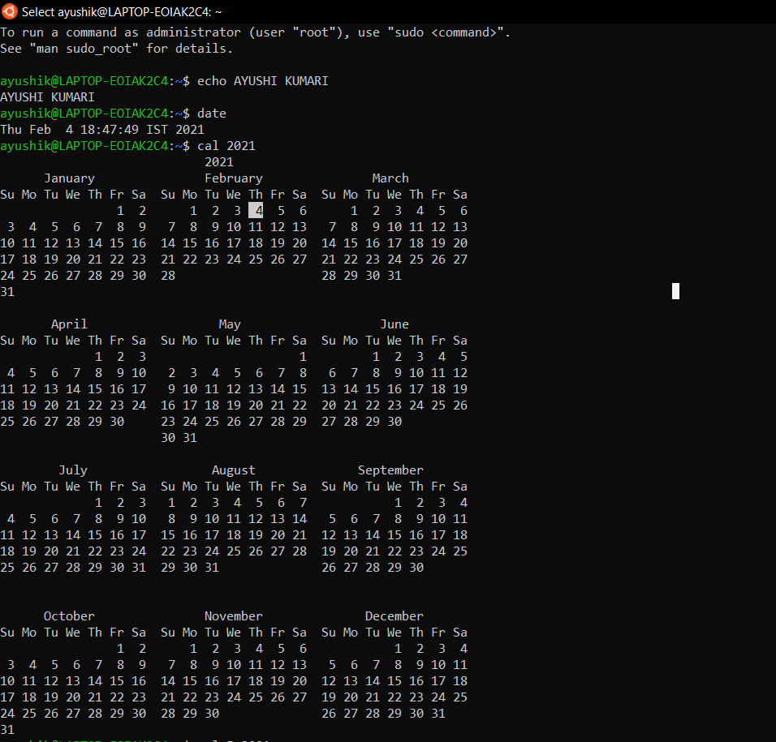

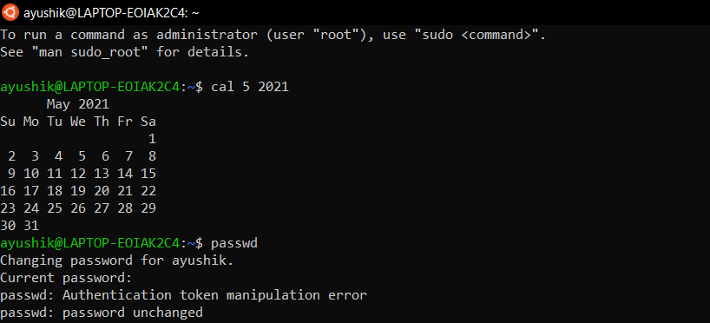

1. **Working with Files.**

1. ls: lists files in the current directory

ls -l: lists files with detailed info

ls -a: lists all files including hidden files

2. cat > f1: creates a new file

3. cat f1: displays the content in file f1

4. wc f1: lists no. of characters, words & lines in file f1

wc -c f1: lists only no. of characters in f1

wc -w f1: lists only no. of words in f1

5. cp f1 f2: copies file f1 into f2

6. mv f1 f2: renames file f1 as f2

7. rm f1: removes file f1

8. head -5 f1: lists first 5 lines in f1

tail -3 f1: lists last 5 lines in f1.

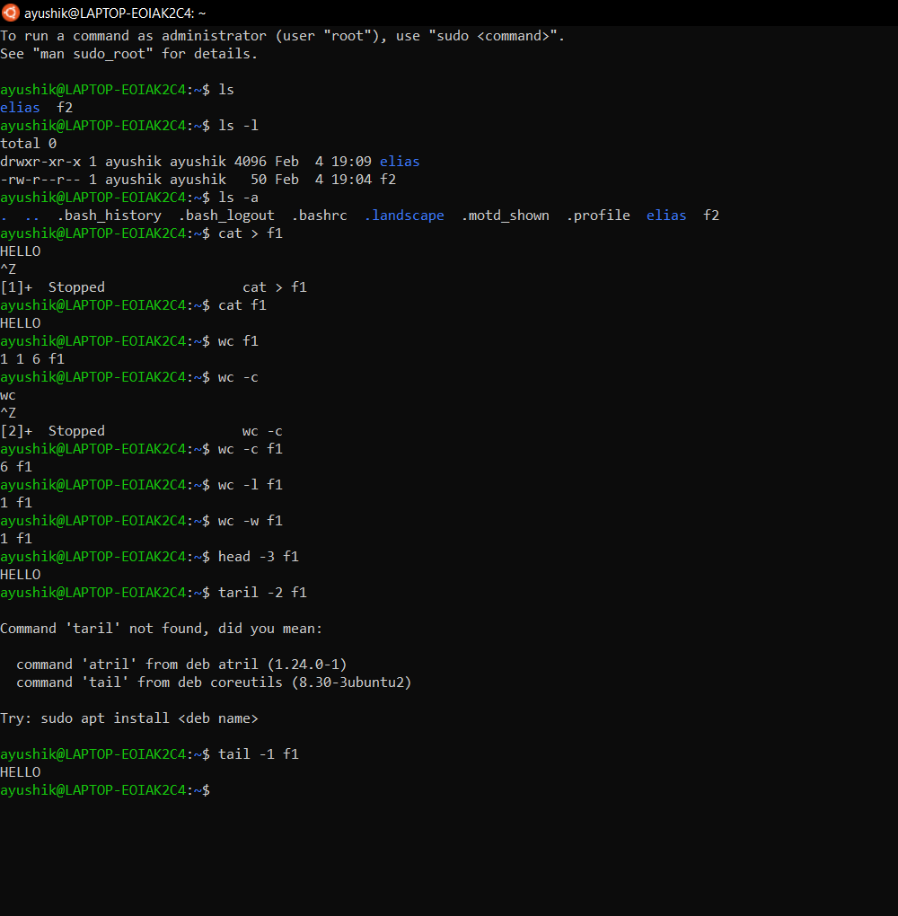

1. **Working with Directories.**

1. mkdir happy: creates directory named happy

2. cd happy: changes directory as happy

3. rmdir happy: removes the directory happy

4. pwd : displays path of present working directory

5. cd: goes to home directory

cd.. : goes to parent directory

cd - : goes to previous working directory

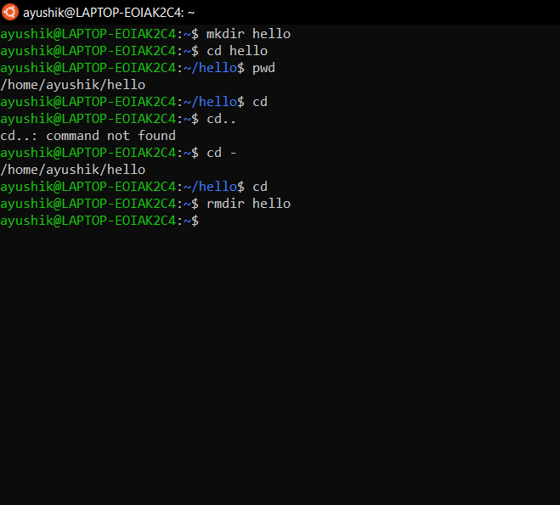

1. **Working with Substitution.**

1. ls f? : lists files that start with ‘f’ and

followed by any one character

2. ls *.c : lists files with extension ‘c’

3. ls [gpy]et : lists files whose starting letter is

either g,p,y and et follows

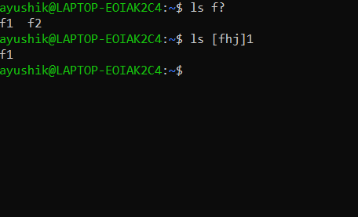

1. **I/O Redirection.**

1. Input redirection

wc -l < exl : finds no. of lines in ex1

2. Output redirection

who > f2 : output of ‘who’ redirected to f2

3. cat >> f1 : appends more into f1

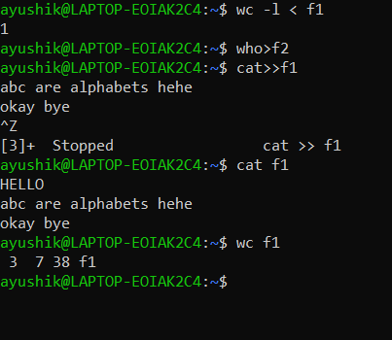

1. **Piping.**

Syntax: command1 | command 2

Output of command1 is transferred to the command2 as input. Finally output of command 2 will be displayed on the monitor.

Ex: cat f1 | more : list the contents of file f1 screen by screen.

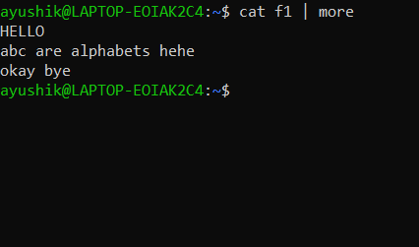

1. **Environment Variables.**

1. echo $HOME: displays path of home directory.

2. echo $PS1: displays the prompt string $.

3. echo $PS2: displays second prompt string.

4. echo $LOGNAME: login name.

5. echo $PATH: list of path name where OS searches for file.

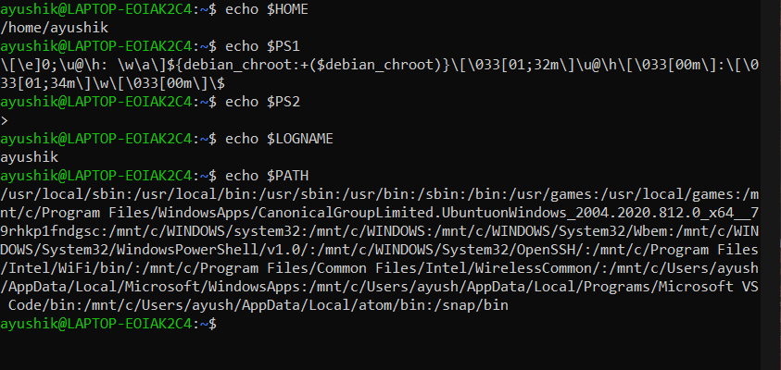

1. **File Permission.**

--chmod command is used to change the access

permission of a file. Method 1:

Syntax: chmod [ugo] [+/-] [rwxa] filename

u: user, g: group, o:others

+: Add permission -: remove permission

r: read, w:write , x: execute, a: all permissions

Ex: chmod ug+rw f1: adding ‘read&write’

permissions of f1 to both user and group members

Method 2:

Syntax: chmod octnum file1

The 3-digit octal number represents as follows:

First digit: file permissions for the user



